**Install Python Step-by-Step in Windows and Mac :**

Python a versatile programming language doesn’t come pre-installed on your computer devices. Python was first released in the year 1991 and until today it is a very popular high-level programming language. Its style philosophy emphasizes code readability with its notable use of great whitespace.

The object-oriented approach and language construct provided by Python enables programmers to write both clear and logical code for projects. This software does not come pre-packaged with Windows.

## How to Install Python on Windows and Mac :

There have been several updates in the Python version over the years. The question is how to install Python? It might be confusing for the beginner who is willing to start learning Python but this tutorial will solve your query. The latest or the newest version of Python is version 3.7.4 or in other words, it is Python 3.

**Note:** The python version 3.7.4 cannot be used on Windows XP or earlier devices.

Before you start with the installation process of Python. First, you need to know about your **System Requirements**. Based on your system type i.e. operating system and based processor, you must download the python version. My system type is a **Windows 64-bit operating system**. So the steps below are to install python version 3.7.4 on Windows 7 device or to install Python 3. [Download the Python Cheatsheet here.](https://myelearninghub.com/python-cheat-sheet/)The steps on how to install Python on Windows 10, 8 and 7 are **divided into 4 parts** to help understand better.

### Download the Correct version into the system

**Step 1:** Go to the official site to download and install python using Google Chrome or any other web browser. OR Click on the following link: [**https://www.python.org**](https://www.python.org/)

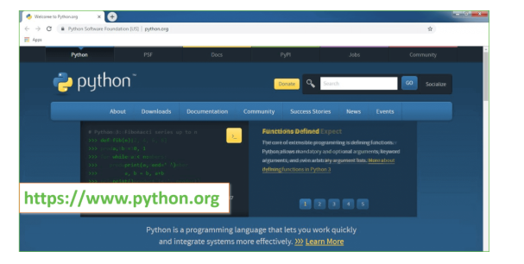

Now, check for the latest and the correct version for your operating system.

**Step 2:** Click on the Download Tab.

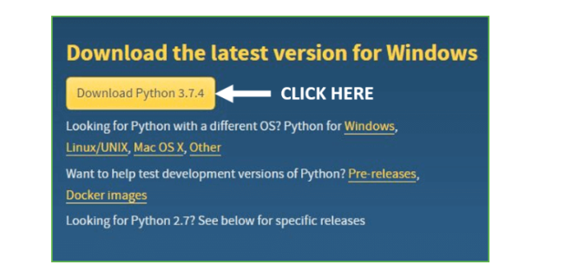

**Step 3:** You can either select the Download Python for windows 3.7.4 button in Yellow Color or you can scroll further down and click on download with respective to their version. Here, we are downloading the most recent python version for windows 3.7.4

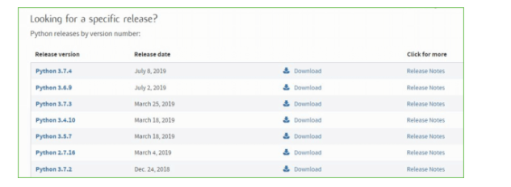

**Step 4:** Scroll down the page until you find the Files option.

**Step 5:** Here you see a different version of python along with the operating system.

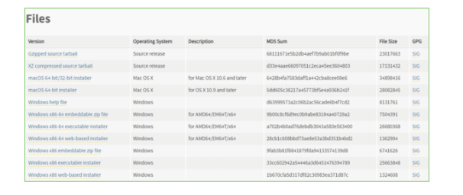

• To download Windows 32-bit python, you can select any one from the three options: Windows x86 embeddable zip file, Windows x86 executable installer or Windows x86 web-based installer.

•To download Windows 64-bit python, you can select any one from the three options: Windows x86-64 embeddable zip file, Windows x86-64 executable installer or Windows x86-64 web-based installer.

Here we will install Windows x86-64 web-based installer. Here your first part regarding which version of python is to be downloaded is completed. Now we move ahead with the second part in installing python i.e. Installation

**Note:** To know the changes or updates that are made in the version you can click on the Release Note Option.

### Installation of Python

**Step 1:** Go to Download and Open the downloaded python version to carry out the installation process.

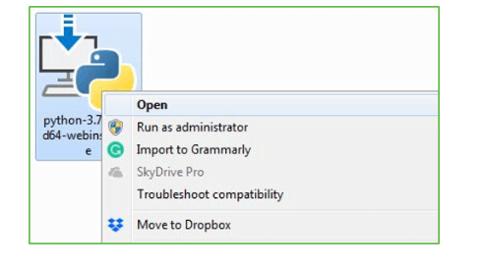

**Step 2:** Before you click on Install Now, Make sure to put a tick on Add Python 3.7 to PATH.

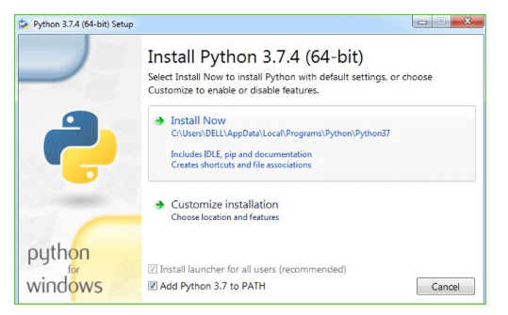

**Step 3:** Click on Install NOW After the installation is successful. Click on Close.

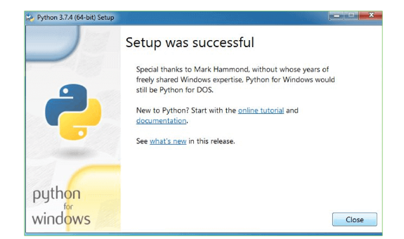

With these above three steps on python installation, you have successfully and correctly installed Python. Now is the time to verify the installation.

**Note:** The installation process might take a couple of minutes.

### Verify the Python Installation

**Step 1:** Click on Start

**Step 2:** In the Windows Run Command, type “cmd”.

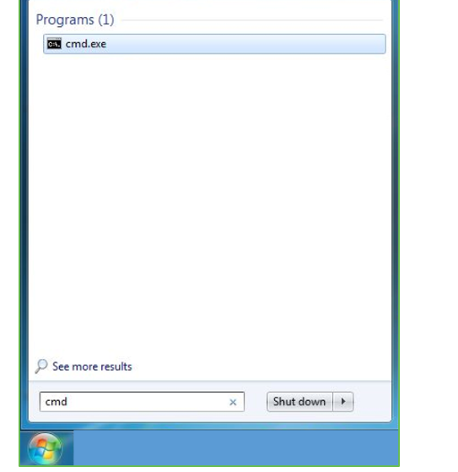

**Step 3:** Open the Command prompt option.

**Step 4:** Let us test whether the python is correctly installed. Type **python –V** and press Enter.

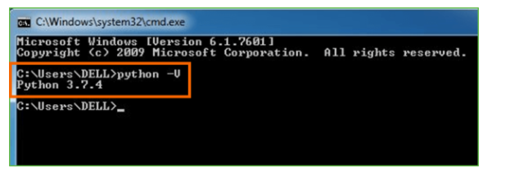

**Step 5:** You will get the answer as 3.7.4

**Note:** If you have any of the earlier versions of Python already installed. You must first uninstall the earlier version and then install the new one.

### Check how the Python IDLE works

**Step 1:** Click on Start

**Step 2:** In the Windows Run command, type “python idle”.

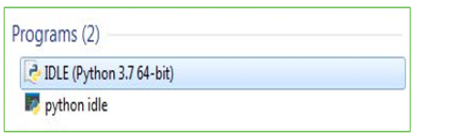

**Step 3:** Click on IDLE (Python 3.7 64-bit) and launch the program

**Step 4:** To go ahead with working in IDLE you must first save the file. **Click on File > Click on Save**

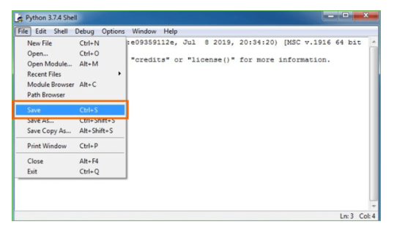

**Step 5:** Name the file and save as type should be Python files. Click on SAVE. Here I have named the files as Hey World.

**Step 6:** Now for e.g. **enter print**

**6.SYSTEM TEST**

The purpose of testing is to discover errors. Testing is the process of trying to discover every conceivable fault or weakness in a work product. It provides a way to check the functionality of components, sub assemblies, assemblies and/or a finished product It is the process of exercising software with the intent of ensuring that the Software system meets its requirements and user expectations and does not fail in an unacceptable manner. There are various types of test. Each test type addresses a specific testing requirement.

### **TYPES OF TESTS**

**Unit testing**

Unit testing involves the design of test cases that validate that the internal program logic is functioning properly, and that program inputs produce valid outputs. All decision branches and internal code flow should be validated. It is the testing of individual software units of the application .it is done after the completion of an individual unit before integration. This is a structural testing, that relies on knowledge of its construction and is invasive. Unit tests perform basic tests at component level and test a specific business process, application, and/or system configuration. Unit tests ensure that each unique path of a business process performs accurately to the documented specifications and contains clearly defined inputs and expected results.

**Integration testing**

Integration tests are designed to test integrated software components to determine if they actually run as one program. Testing is event driven and is more concerned with the basic outcome of screens or fields. Integration tests demonstrate that although the components were individually satisfaction, as shown by successfully unit testing, the combination of components is correct and consistent. Integration testing is specifically aimed at exposing the problems that arise from the combination of components.

**Functional test**

Functional tests provide systematic demonstrations that functions tested are available as specified by the business and technical requirements, system documentation, and user manuals.

Functional testing is centered on the following items:

Valid Input : identified classes of valid input must be accepted.

Invalid Input : identified classes of invalid input must be rejected.

Functions : identified functions must be exercised.

Output : identified classes of application outputs must be exercised.

Systems/Procedures : interfacing systems or procedures must be invoked.

Organization and preparation of functional tests is focused on requirements, key functions, or special test cases. In addition, systematic coverage pertaining to identify Business process flows; data fields, predefined processes, and successive processes must be considered for testing. Before functional testing is complete, additional tests are identified and the effective value of current tests is determined.

**System Test**

System testing ensures that the entire integrated software system meets requirements. It tests a configuration to ensure known and predictable results. An example of system testing is the configuration oriented system integration test. System testing is based on process descriptions and flows, emphasizing pre-driven process links and integration points.

**White Box Testing**

White Box Testing is a testing in which in which the software tester has knowledge of the inner workings, structure and language of the software, or at least its purpose. It is purpose. It is used to test areas that cannot be reached from a black box level.

**Black Box Testing**

Black Box Testing is testing the software without any knowledge of the inner workings, structure or language of the module being tested. Black box tests, as most other kinds of tests, must be written from a definitive source document, such as specification or requirements document, such as specification or requirements document. It is a testing in which the software under test is treated, as a black box .you cannot “see” into it. The test provides inputs and responds to outputs without considering how the software works.

**Unit Testing**

Unit testing is usually conducted as part of a combined code and unit test phase of the software lifecycle, although it is not uncommon for coding and unit testing to be conducted as two distinct phases.

**Test strategy and approach**

Field testing will be performed manually and functional tests will be written in detail.

**Test objectives**

* All field entries must work properly.
* Pages must be activated from the identified link.
* The entry screen, messages and responses must not be delayed.

**Features to be tested**

* Verify that the entries are of the correct format
* No duplicate entries should be allowed
* All links should take the user to the correct page.

# Integration Testing

Software integration testing is the incremental integration testing of two or more integrated software components on a single platform to produce failures caused by interface defects.

The task of the integration test is to check that components or software applications, e.g. components in a software system or – one step up – software applications at the company level – interact without error.

**Test Results:** All the test cases mentioned above passed successfully. No defects encountered.

**Acceptance Testing**

User Acceptance Testing is a critical phase of any project and requires significant participation by the end user. It also ensures that the system meets the functional requirements.

**Test Results:** All the test cases mentioned above passed successfully. No defects encountered.

**Test Cases**

**USER REQUIREMENTS:**

1. Home

|  |  |
| --- | --- |
| Use case ID | A Sentiment Analysis Model for Faculty Comment Evaluation Using Ensemble Machine Learning Algorithms |
| Use case Name | Home button |
| Description | Display home page of application |
| Primary actor | User |
| Precondition | User must open application |
| Post condition | Display the Home Page of an application |
| Frequency of Use case | Many times |
| Alternative use case | N/A |
| Use case Diagrams |  |
| Attachments | N/A |

**7.SCREENSHOTS**

**Step 1** – Importing Libraries

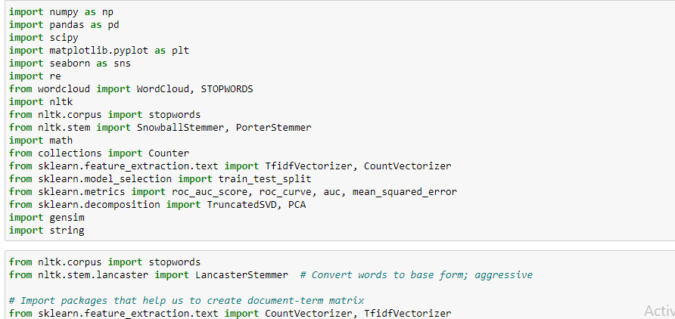

(numpy, pandas for data pre-processing and matplotlib and seaborn for data visualization and nltk for text pre-processing and sklearn for model building).

**Step 2** – Importing dataset and removing the unwanted dataset.

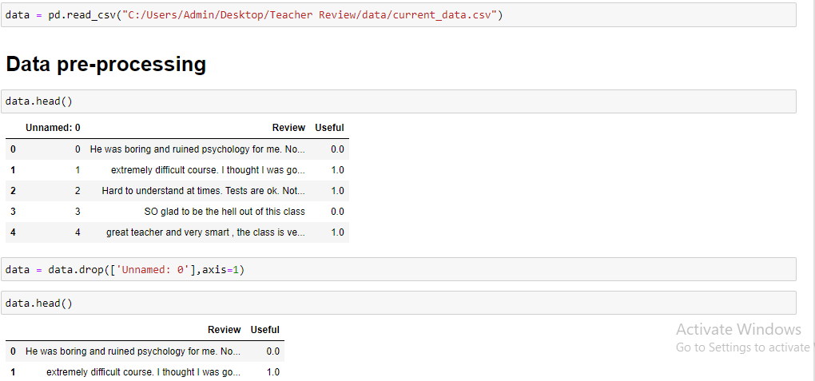

**Step 3** – Printing the most used words for the dataset using wordCloud

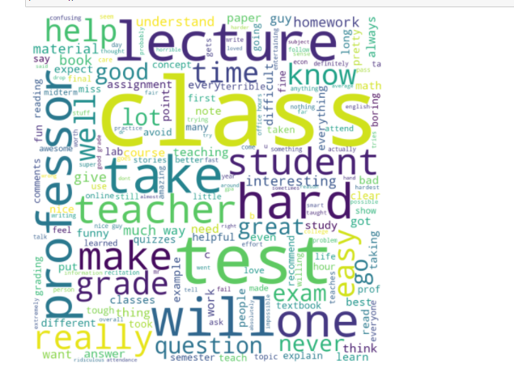

**Step 4** – Text Preprocessing

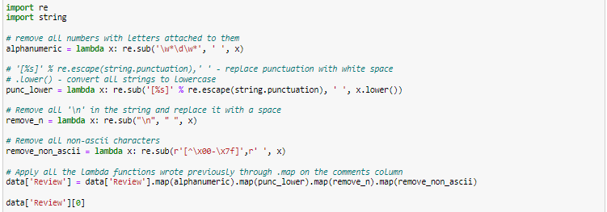

(To remove all the letters, punctuation, spaces, non-ascii characters).

**Step 5** – **Assigning the values to the variables for model building and apply vectorizer on X values.**

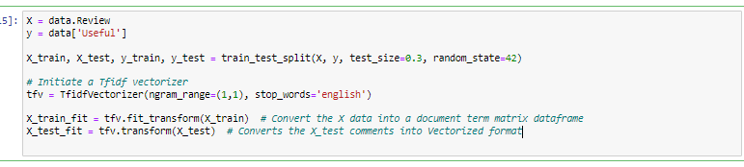

X is assigned to Reviews and y to Useful.

**Step 6** – Apply algorithms

1. SVM
2. Random Forest Classifier
3. Decision tree classifier
4. Knn
5. Logistic regression
6. Naïve Bayes
7. SVM- Linear
8. SVM – Poly
9. SVM – Gaussian
10. SVM – Sigmoid
11. Voting Classifier

**Step 7** – Accuracy comparison

